Upload and Commit from GitHub

Non-developer users primarily work within the products documentation repositories. To simplify their workflow, it is recommended to use GitHub’s native feature of uploaded and adding files to a repository’s directory .

## Upload a New File

Uploading a file is ideal for single files changes or uploads of binary files (document’s, spreadsheets, presentations)

1. From the <>Code tab, select the branch the file(s) is to be added or updated to

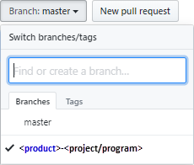

1. Navigate to the path the file(s) is to be added or updated to
2. Select “**Upload files**”

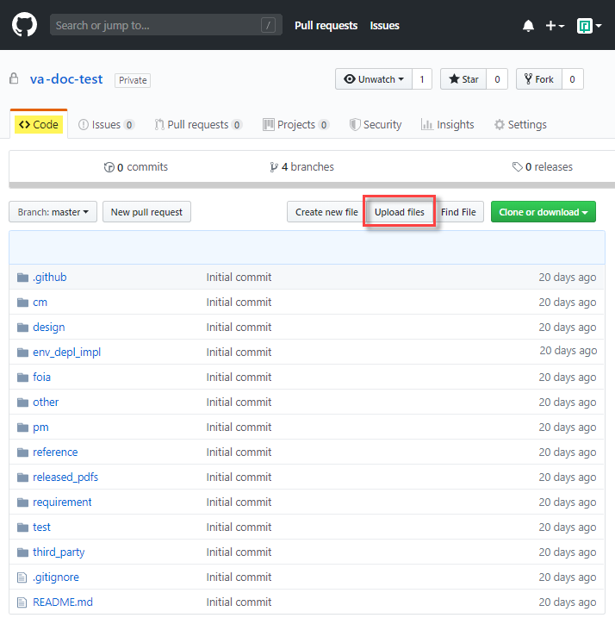

1. Open in Windows Explorer to the location of the file to be added   
   or  
   to the file which was previously downloaded to be worked on
2. Drag and drop onto the GitHub commit page or choose your file(s)

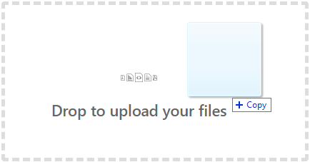

1. In the field “Add files via upload”, enter an issue number and brief description

**Note: GitHub recognizes a reference to an issue numbers in the current repository and will hyperlink the reference once committed. For example “#1Example Issue”**

1. In the field “Add an optional extended description” add further details if necessary.
2. Select the radio button for “Commit directly to the <**product**>-<**project/program**> branch

**Note: Choosing the option “ Create a new branch for ….”. requires a pull request for the commit. In a product repository, pull requests are recommended for promotion to the master branch only.**

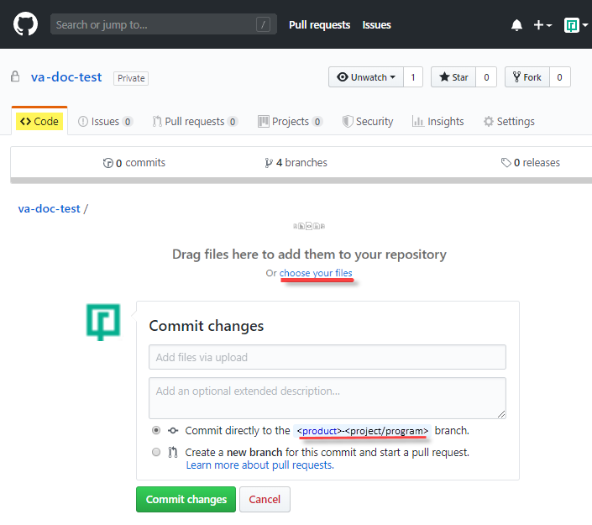

1. Github will indicate thet it is “Processing your files …”, and return the user to the directory the file is uploaded to and show the commit changes brief description

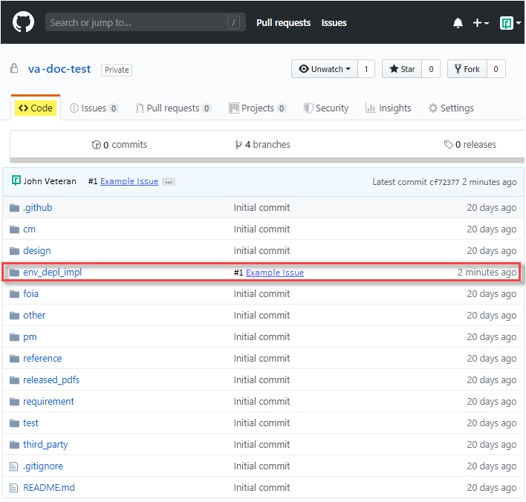

## Updating a File

It is recommended if you are updating a file, the user should download the file locally in a designated local directory. The changes are applied/saved and the steps for updating are the same as uploading a new file.

We will add more details once they are avalliable.